
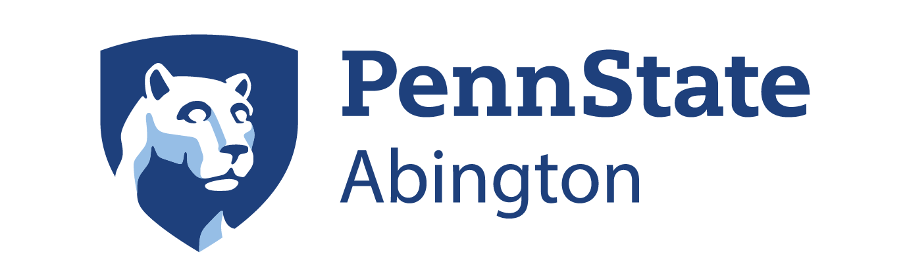
Matthew Fury
Dean of Academic Affairs
First Place Award
Jonathan Alavez
Undergraduate Research Fair
April 15, 2025
Yi Yang
Undergraduate Research Coordinator

